**Hierarchy of folders**

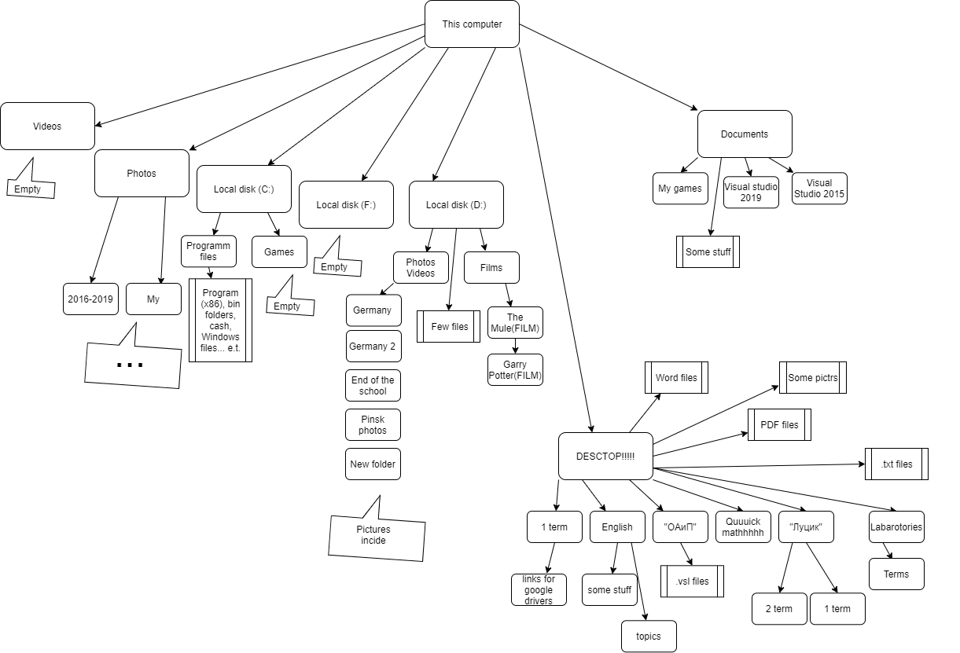

Almost all information I need NOW I keep on my desktop. For me it’s very convenient, all important files, screenshots, presentations, visual studios projects are located on it. I have quick access for files. I can open them fast, change them, and delete unnecessary. I know that desktop storage is located on disk C. Different games or huge files can make harm my computer’s perfomance, so I don't do this. I have my the most common use apps on my taskbar. I usually don’t work with drives. All needed tabs are on my desktop. I don’t scare to break some system files, cause they all are keeping at the separate folders. There are many things that I want to change in hierarchy of my drives. Even one drive I have is empty… I need to delete one. That’s because of my style of “desktoping work”. I should storage my photos and pctrs in one place, I thing that’ll better for me. Folders should contain similar applications… Some folders are empty, I need to delete them, too. Also I can devide my documents for study on terms.

So I need to “clean up”.